
ABSAR AHMED CHOHAN
LAB 1

1: Create a simple HTML webpage that serves as a personal homepage. The webpage should include a main heading with your name, a short paragraph introducing yourself, and a bulleted list of three hobbies or favorite activities. Additionally, add a hyperlink to a website you like and an image that represents one of your hobbies. Save the file as homepage.html.
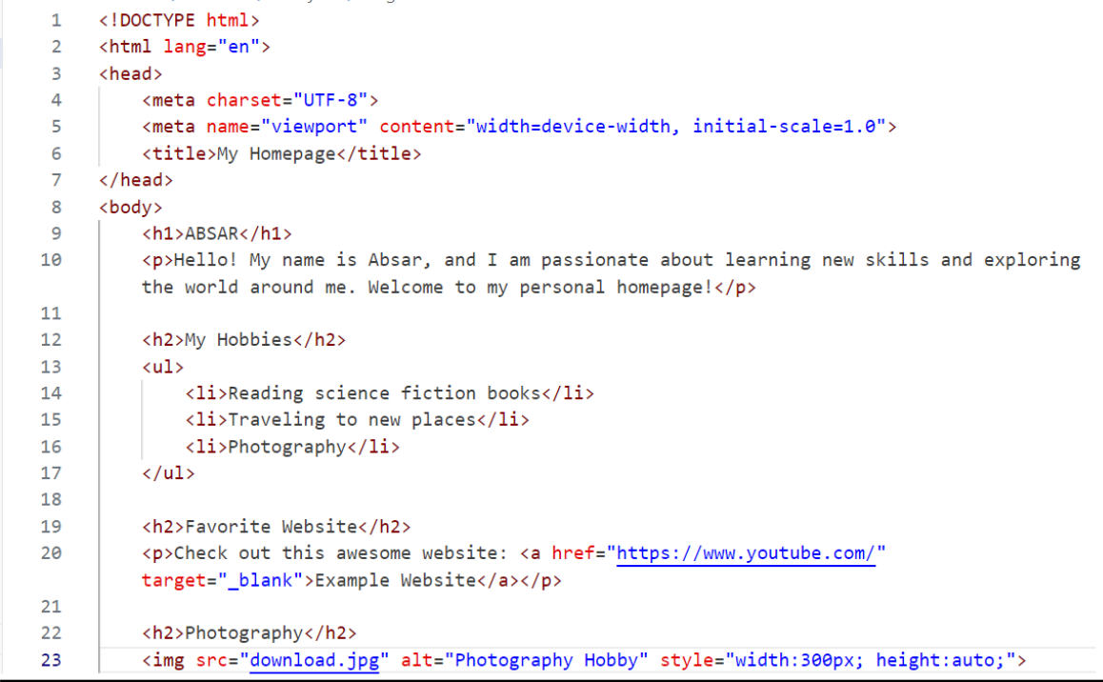
Source Code:
OUTPUT:
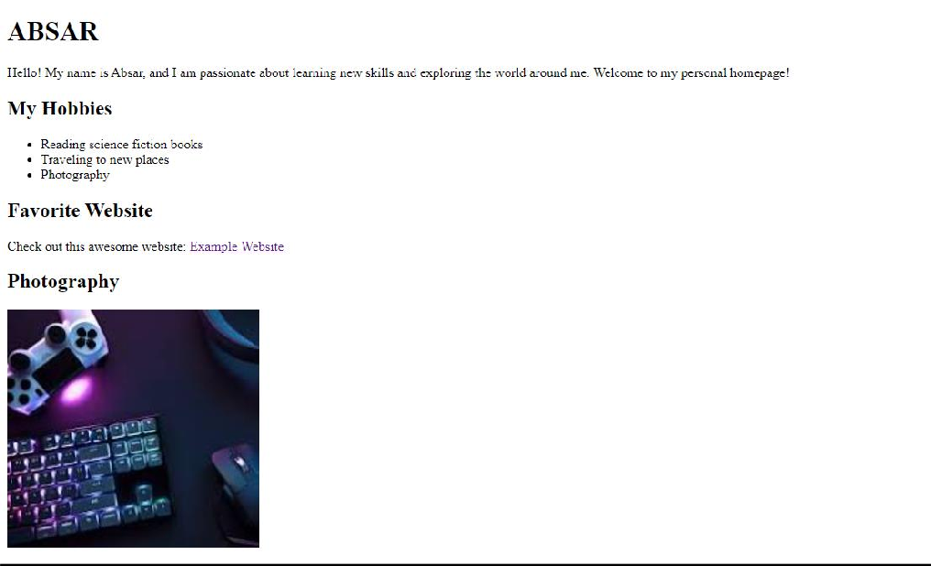

2:: Design a basic personal portfolio website consisting of two HTML pages. The first page should include a welcome message, a brief introduction, and a list of your top three favorite books or movies. The second page should contain a small gallery with three images of your choice and a heading above each image to describe it. Save the pages as index.html and gallery.html, and store them in a folder named PortfolioWebsite.

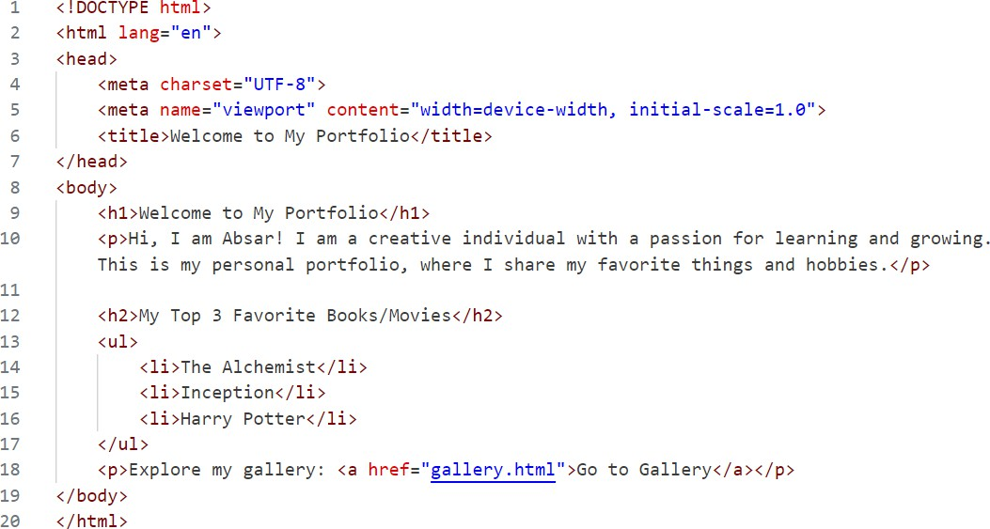
Source Code:

OUTPUT:
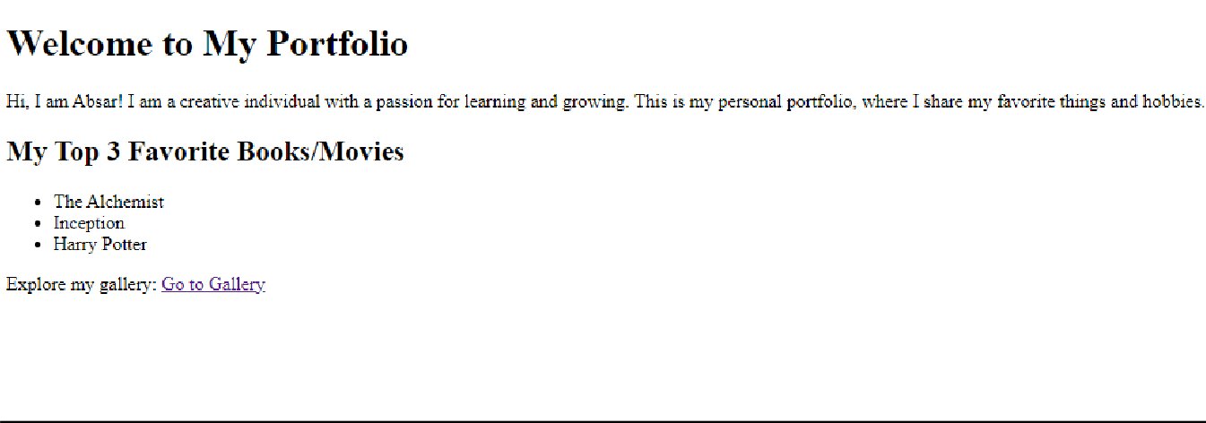

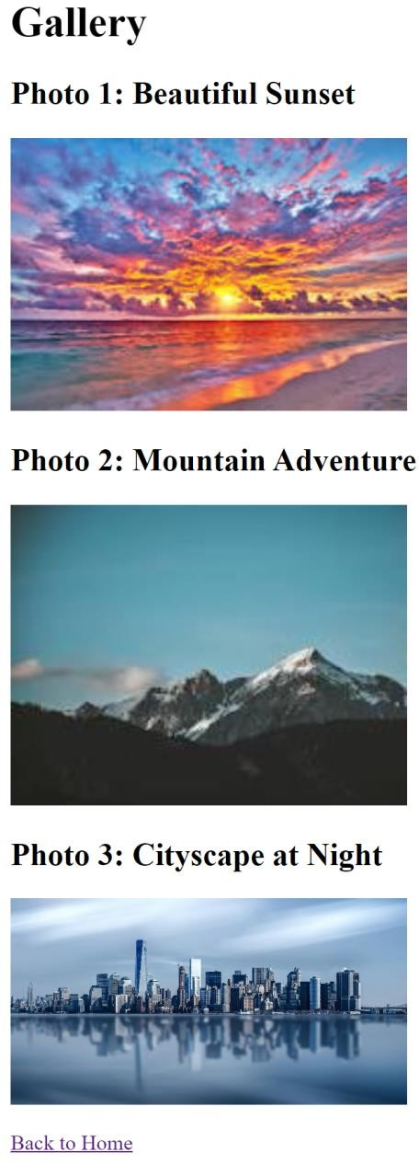


ABSAR AHMED CHOHAN
LAB 2

1: Create a webpage that includes a timetable of your weekly classes using an HTML table. The table should have headings for each day of the week and rows for each time slot. Also, include a registration form below the timetable where users can enter their name, email, and select their class timing from a dropdown.
Source Code:
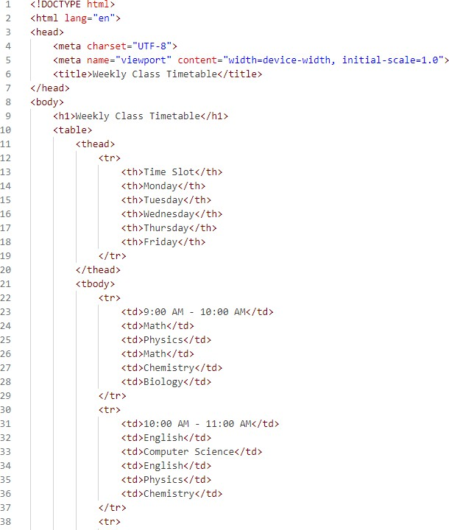
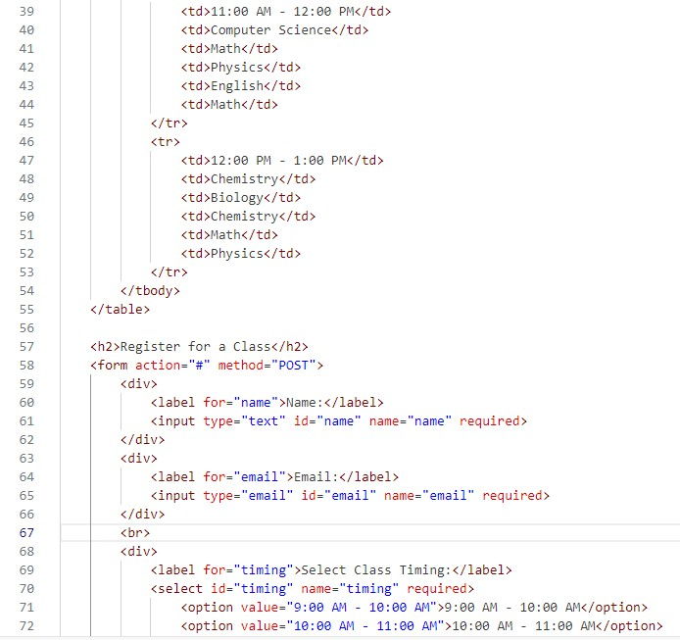

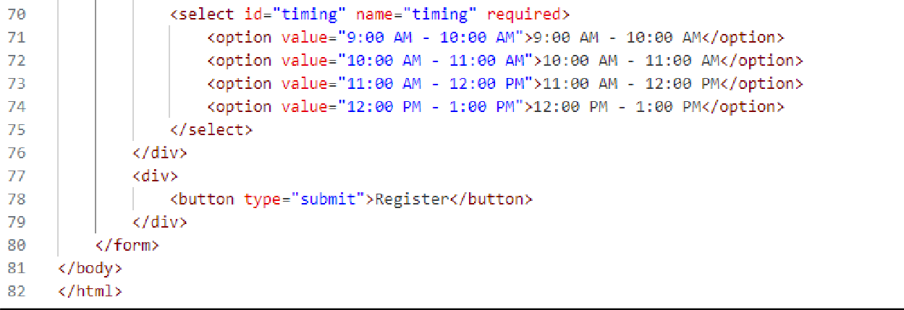
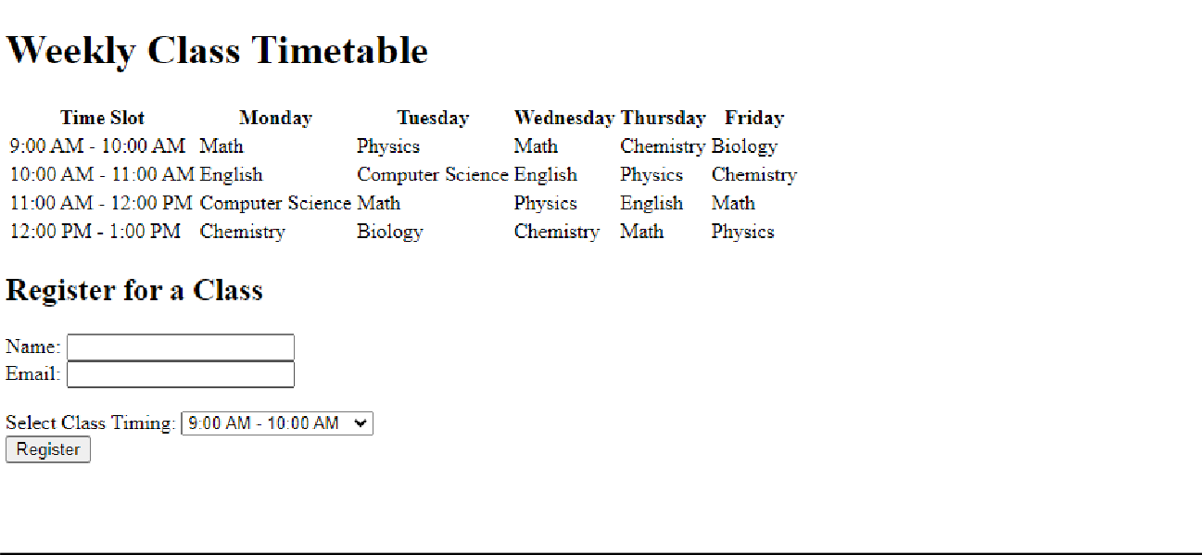
OUTPUT:

2: Design a basic feedback form using HTML. The form should include fields for name, email, feedback message (textarea), and a rating system (radio buttons). Add a submit button at the end and save the file as feedback.html.

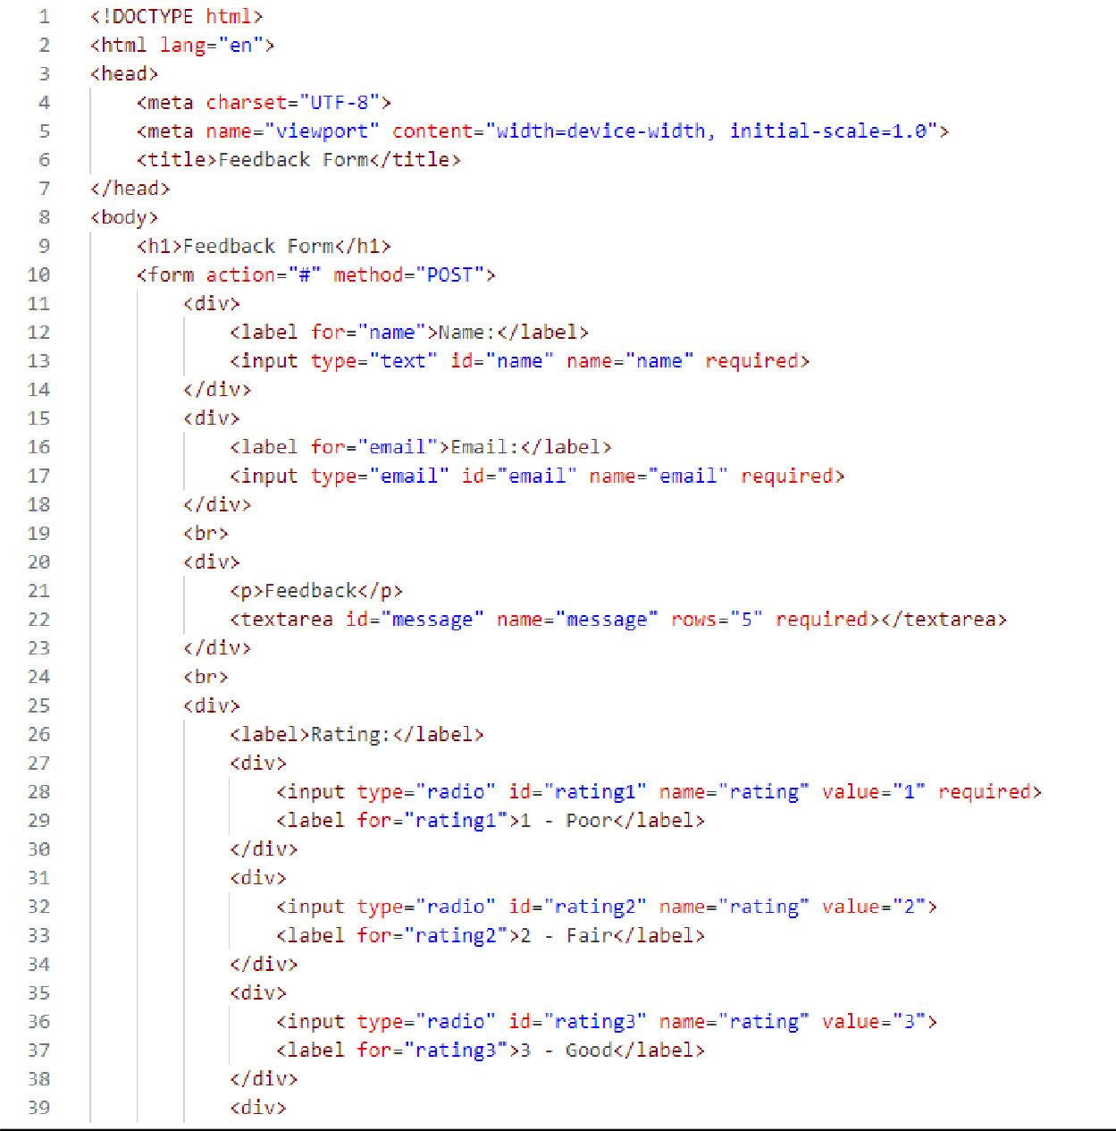
Source Code:

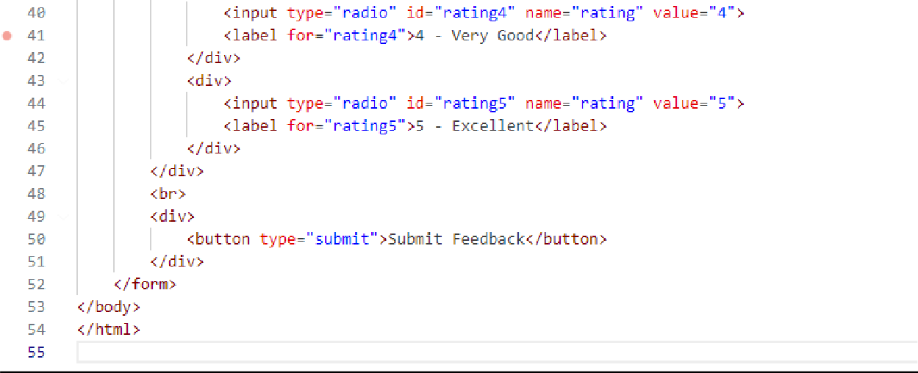
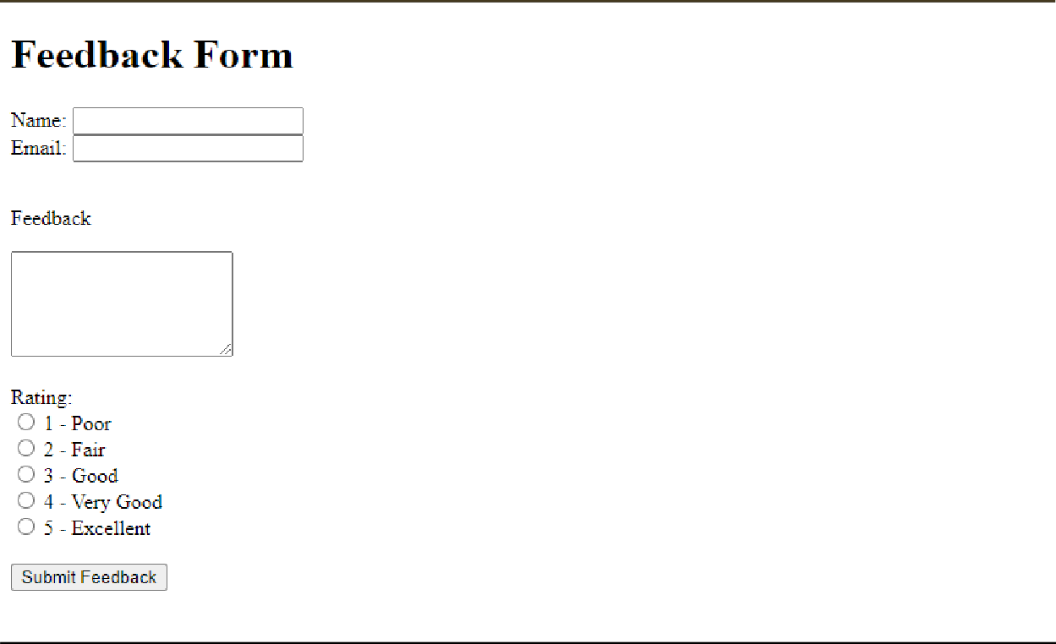
Output:


ABSAR AHMED CHOHAN
LAB 3

1: Design a homepage for a university that includes:
- A main heading styled using internal CSS to display the university name prominently.
- A navigation bar for links like "Home," "About Us," "Departments," and "Contact Us," styled using external CSS.
- A welcome paragraph styled using inline CSS to set a custom font size and background color.

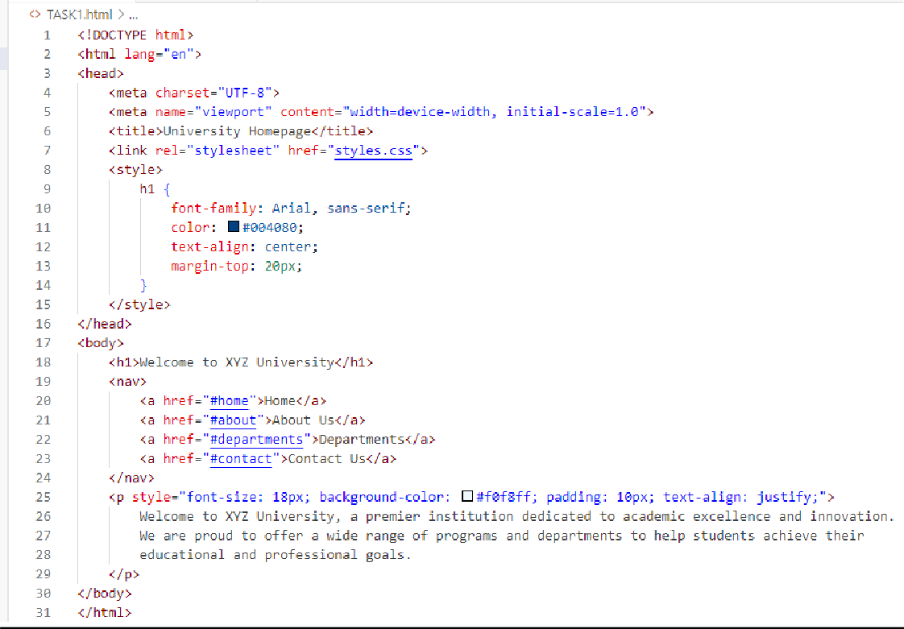
HTML Code:
CSS CODE:
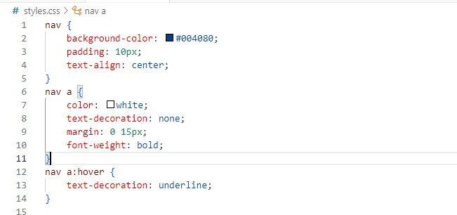


OUTPUT:
2: Create a personal portfolio webpage that includes:
- A main heading with your name, styled using an ID.
- A section for your hobbies, each with a subheading styled using classes.
- A list of your skills (ordered or unordered), with custom styles applied using an external stylesheet.

HTML Code:
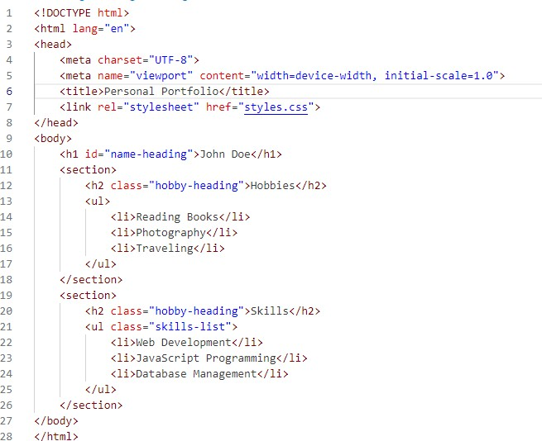

CSS CODE:
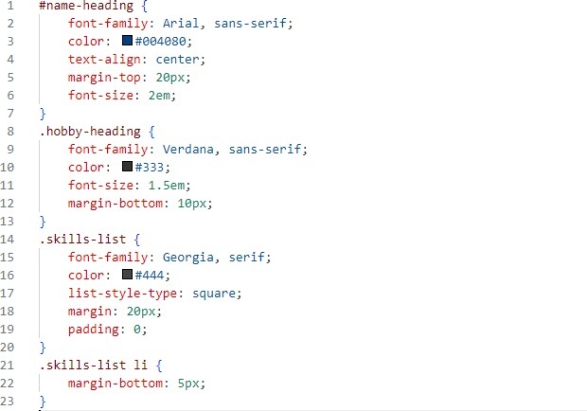

Output:
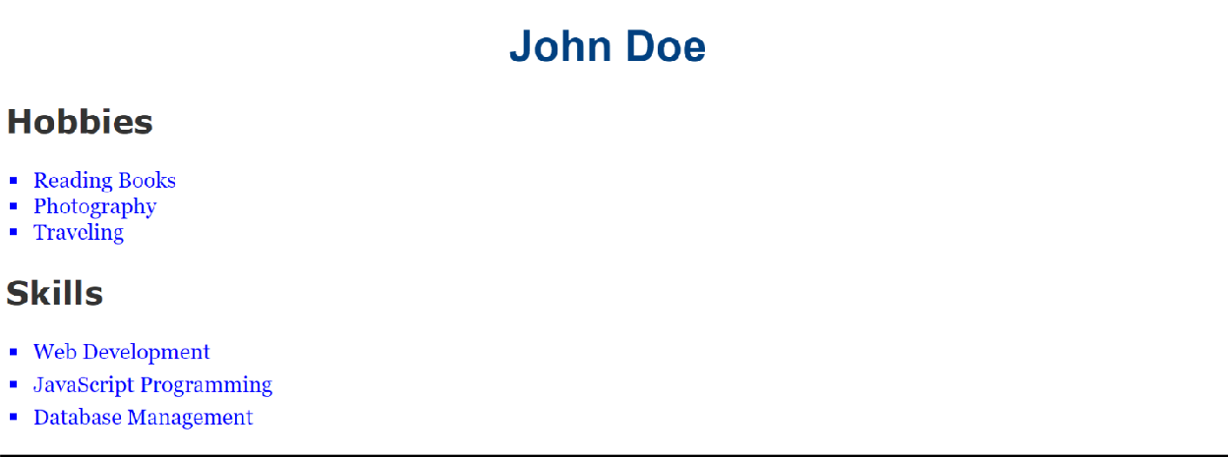


LAB 4

1: Design a product landing page that includes:

- A favicon for the page.
- A header, content section, and footer styled using divs and the Box Model.
- Use relative positioning to adjust the content placement and absolute positioning for a floating "Contact Us" button.
- Style the typography of the page (e.g., font family, size, and line spacing).

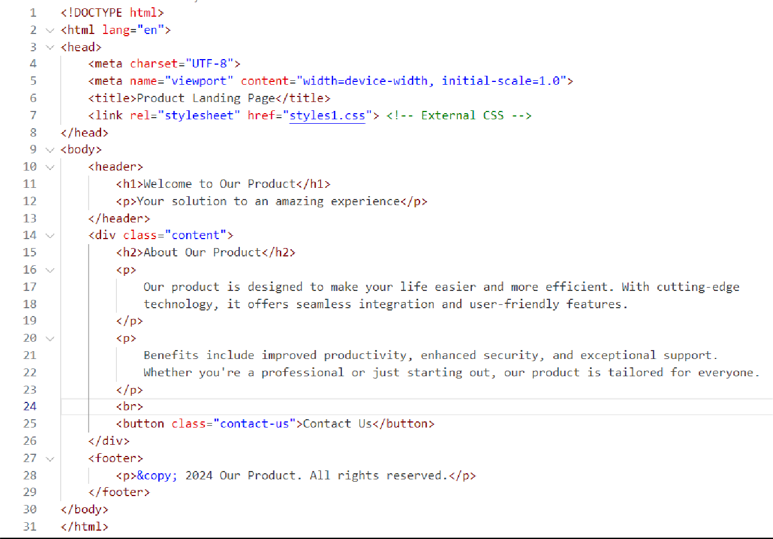
HTML CODE:

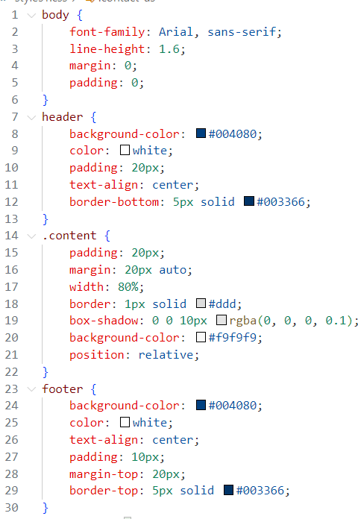
CSS CODE:
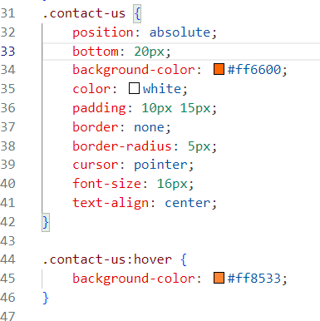

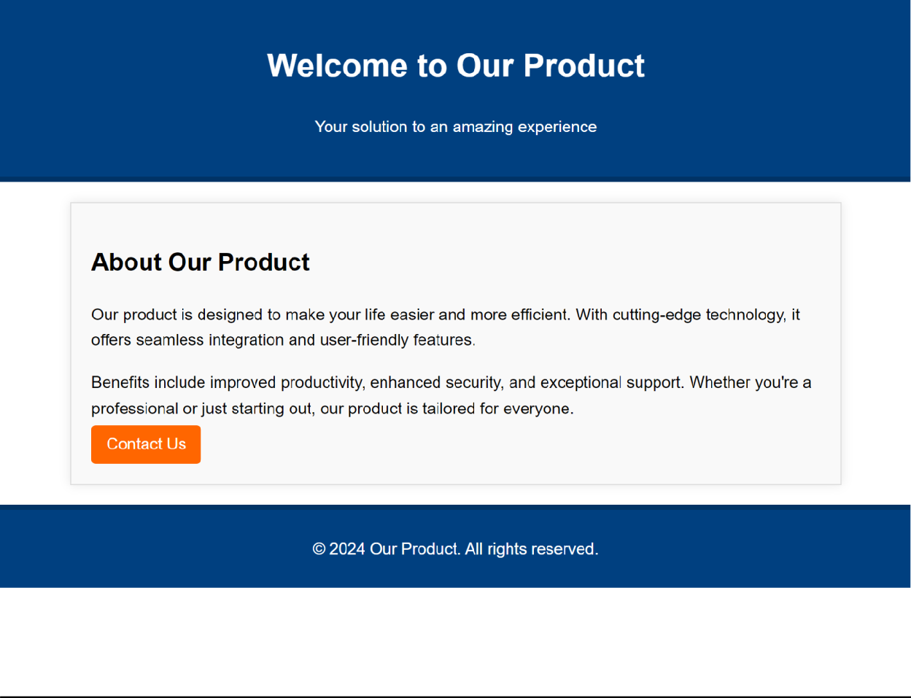
OUTPUT:

2: Design a homepage for a book store that includes:
- A header section with the store name styled using CSS typography.
- A section for featured books, divided into categories using divs.
- Use the Box Model to add padding, borders, and margins to the book sections.
- Include a "Buy Now" button for each book, styled using CSS positioning and typography.
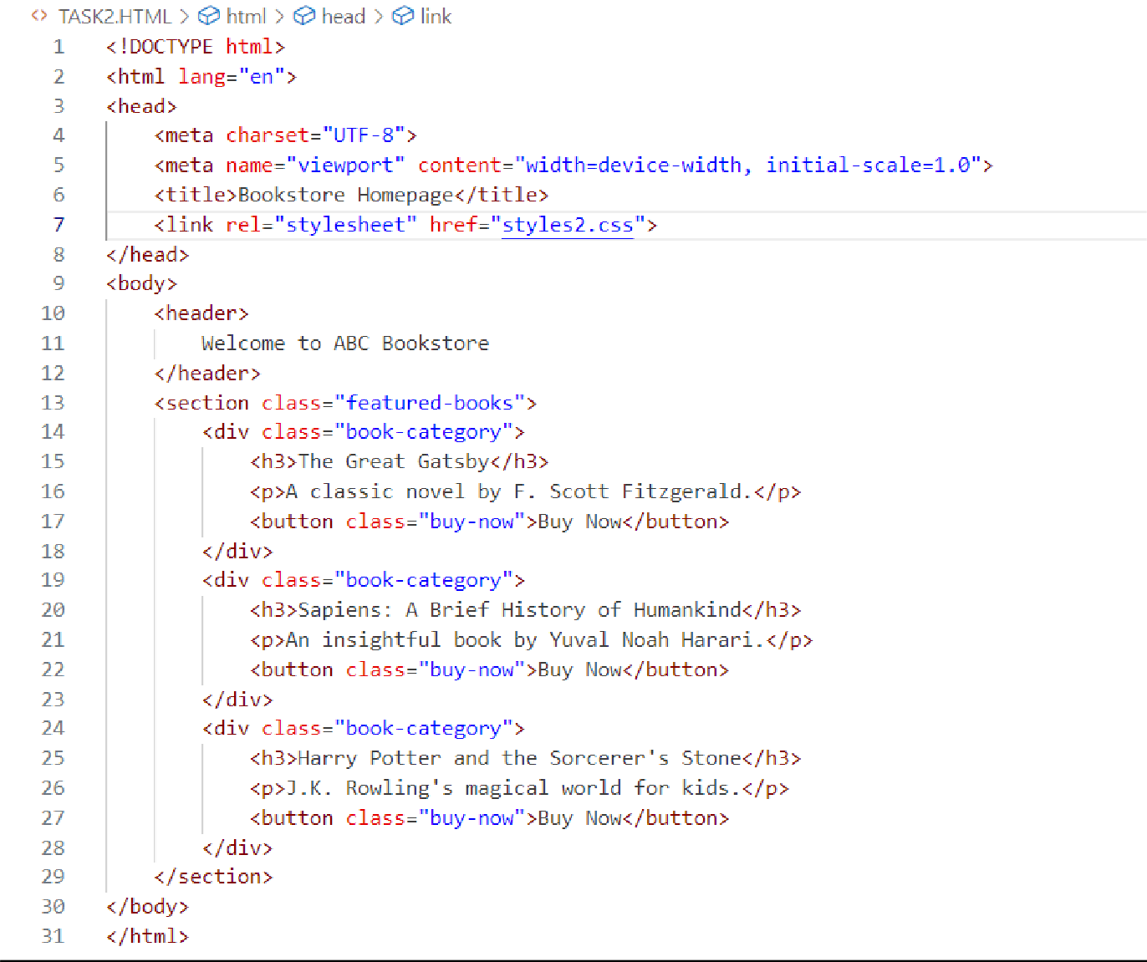
HTML CODE:

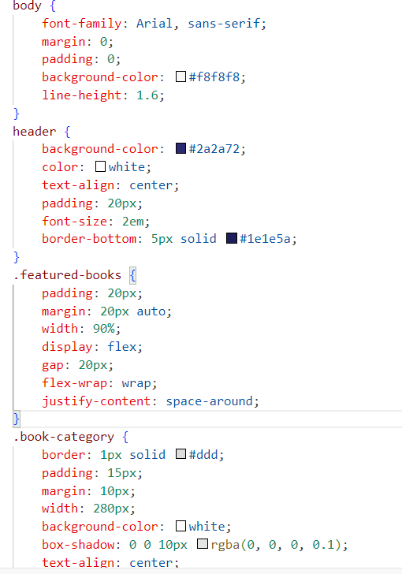
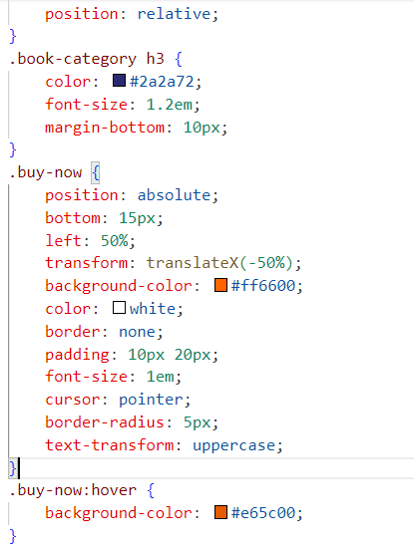
CSS CODE:

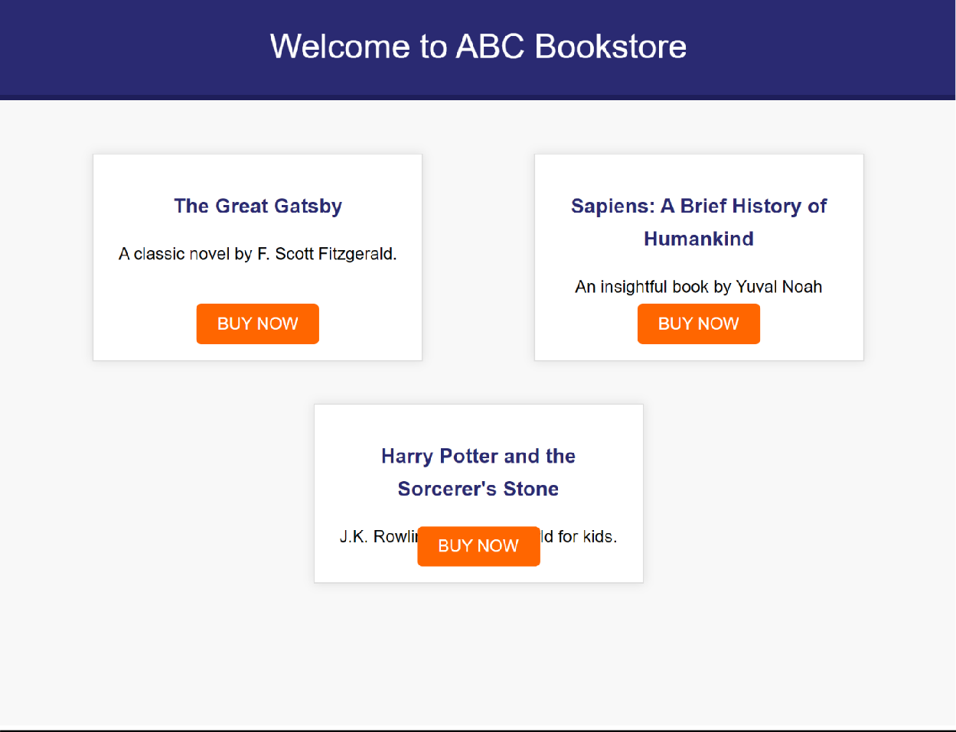
OUTPUT:


LAB TASK:
LAB 5
ABSAR AHMED CHOHAN

SOURCE CODE:
<!DOCTYPE html>
<html lang="en">
<head>
<meta charset="UTF-8">
<meta name="viewport" content="width=device-width, initial-scale=1.0">
<title>Tech Startup</title>
<link href="https://cdn.jsdelivr.net/npm/bootstrap@5.3.1/dist/css/bootstrap.min.css " rel="stylesheet">
</head>
<body>
<nav class="navbar navbar-expand-lg navbar-dark bg-dark">
<div class="container-fluid">
<a class="navbar-brand" href="#">Tech Startup</a>
<button class="navbar-toggler" type="button" data-bs- toggle="collapse" data-bs-target="#navbarNav" aria-controls="navbarNav" aria- expanded="false" aria-label="Toggle navigation">
<span class="navbar-toggler-icon"></span>
</button>
<div class="collapse navbar-collapse" id="navbarNav">
<ul class="navbar-nav">
<li class="nav-item">
<a class="nav-link" href="#">Home</a>
</li>
<li class="nav-item">
<a class="nav-link" href="#">Services</a>
</li>
<li class="nav-item">
<a class="nav-link" href="#">Contact Us</a>
</li>
</ul>
</div>
</div>
</nav>
<div class="container-fluid bg-light text-center py-5">
<h1 class="display-4">Welcome to Our Tech Startup</h1>
<p class="lead">Innovative solutions for a smarter future</p>
<button class="btn btn-primary btn-lg">Learn More</button>

</div>
<div class="container-fluid py-5">
<h2 class="text-center mb-4">Our Services</h2>
<div class="row text-center">
<div class="col-md-4">
<h4>Web Development</h4>
<p>Creating modern, responsive websites.</p>
</div>
<div class="col-md-4">
<h4>App Development</h4>
<p>Custom mobile app solutions.</p>
</div>
<div class="col-md-4">
<h4>AI & Machine Learning</h4>
<p>Cutting-edge AI-driven technologies.</p>
</div>
</div>
</div>
<script src="https://cdn.jsdelivr.net/npm/bootstrap@5.3.1/dist/js/bootstrap.bundle.mi n.js"></script>
</body>
</html>

OUTPUT:
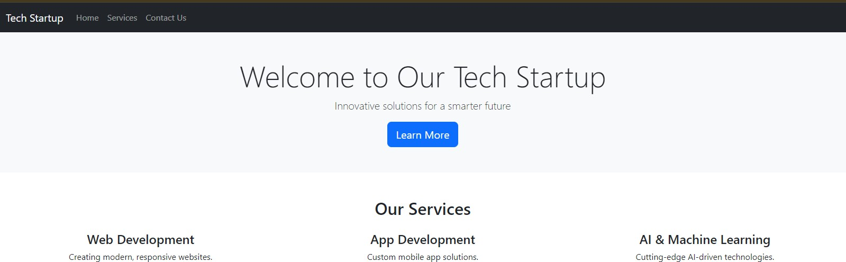

HOME TASK:
SOURCE CODE:
<!DOCTYPE html>
<html lang="en">
<head>
<meta charset="UTF-8">
<meta name="viewport" content="width=device-width, initial-scale=1.0">
<title>Travel Agency</title>
<!-- Bootstrap CSS -->
<link href="https://cdn.jsdelivr.net/npm/bootstrap@5.3.1/dist/css/bootstrap.min.css " rel="stylesheet">
<!-- Font Awesome -->
<link href="https://cdnjs.cloudflare.com/ajax/libs/font-awesome/6.0.0- beta3/css/all.min.css" rel="stylesheet">
</head>
<body>
<nav class="navbar navbar-expand-lg navbar-light bg-light">
<div class="container-fluid">
<a class="navbar-brand" href="#">Travel Agency</a>
<button class="navbar-toggler" type="button" data-bs- toggle="collapse" data-bs-target="#navbarNav" aria-controls="navbarNav" aria- expanded="false" aria-label="Toggle navigation">
<span class="navbar-toggler-icon"></span>
</button>
<div class="collapse navbar-collapse" id="navbarNav">
<ul class="navbar-nav">
<li class="nav-item">
<a class="nav-link" href="#">Home</a>
</li>
<li class="nav-item">
<a class="nav-link" href="#">Packages</a>
</li>
<li class="nav-item">
<a class="nav-link" href="#">Contact Us</a>
</li>
</ul>
</div>
</div>
</nav>
<div class="container py-5">
<h2 class="text-center mb-4">Featured Destinations</h2>

<div class="row">
<div class="col-md-4 text-center">
<img src="destination1.jpg" class="img-fluid rounded mb-3" alt="Destination 1">
<h4>Maldives</h4>
<p>Experience the serene beauty of the islands.</p>
</div>
<div class="col-md-4 text-center">
<img src="destination2.jpg" class="img-fluid rounded mb-3" alt="Destination 2">
<h4>Paris</h4>
<p>Discover the charm of the City of Light.</p>
</div>
<div class="col-md-4 text-center">
<img src="destination3.jpg" class="img-fluid rounded mb-3" alt="Destination 3">
<h4>Japan</h4>
<p>Explore the rich culture and modern marvels.</p>
</div>
</div>
</div>
<footer class="bg-light text-center py-4">
<p><i class="fas fa-phone-alt"></i> +123 456 7890</p>
<p><i class="fas fa-envelope"></i> info@travelagency.com</p>
</footer>
<script src="https://cdn.jsdelivr.net/npm/bootstrap@5.3.1/dist/js/bootstrap.bundle.mi n.js"></script>
</body>
</html>

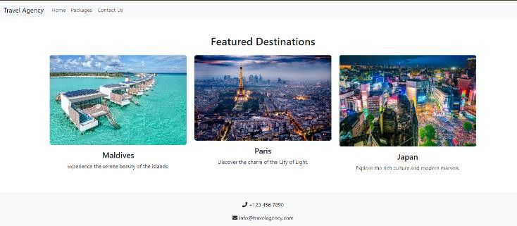
OUTPUT:


ABSAR AHMED CHOHAN
LAB 6

LAB TASK: SOURCE CODE:
<!DOCTYPE html>
<html lang="en">
<head>
<meta charset="UTF-8">
<meta name="viewport" content="width=device-width, initial- scale=1.0">
<title>Lab Task - JavaScript Webpage</title>
<script src="labtask.js"></script>
</head>
<body>
<h1>JavaScript Webpage</h1>
<h2>Form for Personalized Greeting</h2>
<form onsubmit="event.preventDefault(); displayGreeting();">
<label for="nameInput">Enter your name:</label>
<input type="text" id="nameInput" placeholder="Your name">
<button type="submit">Submit</button>
</form>
<p id="greetingMessage" style="font-weight: bold; color: green;"></p>
</body>
</html>

JAVASCRIPT CODE:
window.onload = function () {
alert("Welcome to our webpage!");
};
function displayGreeting() {
const userName = document.getElementById("nameInput").value; if (userName.trim() === "") {
alert("Please enter your name.");
} else {
document.getElementById("greetingMessage").innerText = `Hello,
${userName}! Welcome to our webpage.`;
}
}
console.log("First 10 Natural Numbers:"); for (let i = 1; i <= 10; i++) {
console.log(i);
}

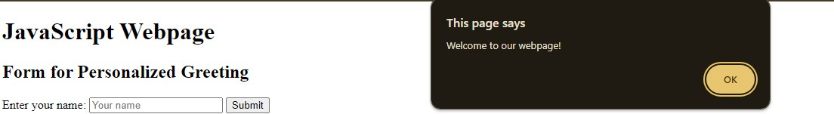
HOME TASK:

SOURCE CODE:
<!DOCTYPE html>
<html lang="en">
<head>
<meta charset="UTF-8">
<meta name="viewport" content="width=device-width, initial- scale=1.0">
<title>Home Task - Even or Odd</title>
</head>
<body>
<h1>Even or Odd Checker</h1>
<button onclick="checkEvenOdd()">Check Number</button>
<script>
// Function to check if a number is even or odd function checkEvenOdd() {
const userInput = prompt("Enter a number:"); const number = parseInt(userInput);

// Validate the input if (isNaN(number)) {
alert("Please enter a valid number.");
} else {
if (number % 2 === 0) {
alert(`The number ${number} is Even.`);
} else {
alert(`The number ${number} is Odd.`);
}
}
}
</script>
</body>
</html>

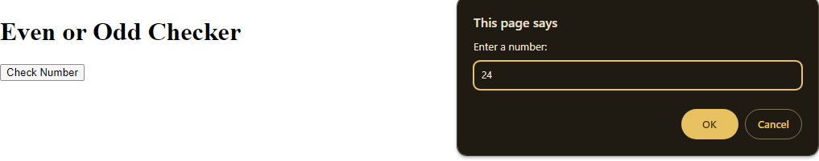

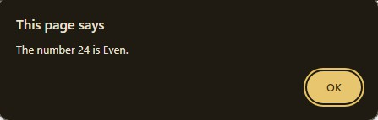


ABSAR AHMED CHOHAN
LAB 7

LAB TASK:

SOURCE CODE:
<!DOCTYPE html>
<html lang="en">
<head>
<meta charset="UTF-8">
<meta name="viewport" content="width=device-width, initial- scale=1.0">
<title>Lab Task</title>
<style>
#changeButton { padding: 10px 20px; font-size: 16px; cursor: pointer; border: none;
background-color: #007bff; color: white;
border-radius: 5px;
transition: background-color 0.3s;
}
</style>
</head>
<body>
<h1>Lab Task Webpage</h1>
<p id="content">This is a sample paragraph.</p>
<button id="changeButton"
onclick="changeParagraphContent()" onmouseover="hoverButton(this)" onmouseout="unhoverButton(this)">
Click Me
</button>
<script>
function changeParagraphContent() {
const paragraph = document.getElementById("content"); paragraph.textContent = "The content of this paragraph has
been changed!";
const newParagraph = document.createElement("p"); newParagraph.textContent = "This is a new paragraph added
dynamically.";
document.body.appendChild(newParagraph);
}

function hoverButton(button) { button.style.backgroundColor = "#0056b3";
}

function unhoverButton(button) { button.style.backgroundColor = "#007bff";
}
</script>
</body>
</html>

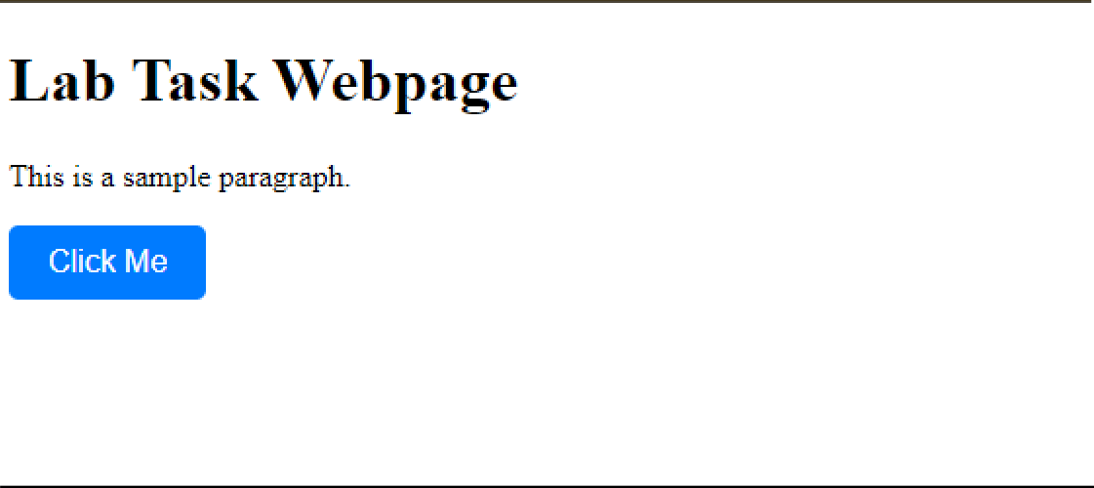
OUTPUT (BEFORE CLICK):
OUTPUT (AFTER CLICK):
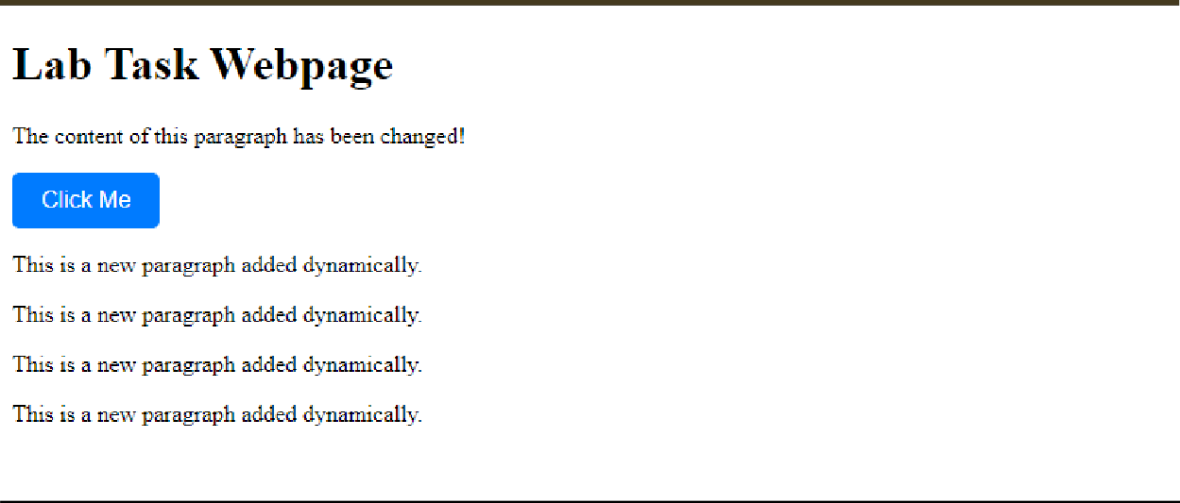

HOME TASK:
SOURCE CODE:
<!DOCTYPE html>
<html lang="en">
<head>
<meta charset="UTF-8">
<meta name="viewport" content="width=device-width, initial-scale=1.0">
<title>Home Task</title>
<style>
#contentArea { padding: 20px;
background-color: #f9f9f9; border: 1px solid #ccc;
}
footer {
text-align: center; padding: 10px;
background-color: #007bff; color: white;
margin-top: 20px;
}
</style>

</head>
<body>
<header>
<h1 id="headerText">Header Section</h1>
<button onclick="updateHeaderText()">Update Header</button>
</header>

<section id="contentArea">
<h2>Content Area</h2>
<p>This is the main content area of the webpage.</p>
<label for="colorSelector">Change Background Color:</label>
<select id="colorSelector" onchange="changeBackgroundColor()">
<option value="#f9f9f9">Default</option>
<option value="#ffcccc">Light Red</option>
<option value="#ccffcc">Light Green</option>
<option value="#ccccff">Light Blue</option>
</select>
</section>
<script>
// Update header text dynamically

function updateHeaderText() { document.getElementById("headerText").textContent = "Updated
Header Text!";
}

// Change background color of content area function changeBackgroundColor() {
const selectedColor = document.getElementById("colorSelector").value;
document.getElementById("contentArea").style.backgroundColor = selectedColor;
}

// Add a new footer dynamically after 5 seconds window.onload = function () {
setTimeout(() => {
const newFooter = document.createElement("footer"); newFooter.textContent = "This is a dynamically added

footer.";

};

document.body.appendChild(newFooter);
}, 5000);

</script>
</body>
</html>

OUTPUT (BEFORE CLICKING):
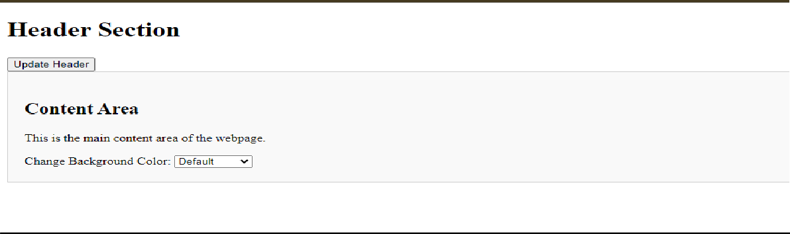
OUTPUT (AFTER CLICKING THE BUTTON AND CHANGING THE COLOR):
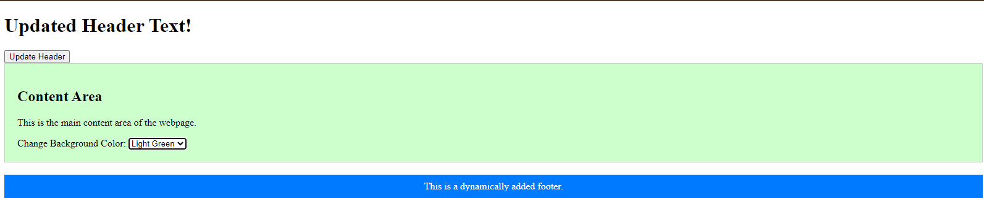


WEB ENGINEERING LAB 2022F-BCS-066
LAB 8
ABSAR AHMED CHOHAN

LAB TASK:

SOURCE CODE:
<!DOCTYPE html>
<html lang="en">
<head>
<meta charset="UTF-8">
<meta name="viewport" content="width=device-width, initial-scale=1.0">
<title>Lab Task - Student List</title>
<script src="https://ajax.googleapis.com/ajax/libs/jquery/3.7.1/jquery.min.js"></script>
<style>
#studentSection { margin: 20px;
border: 1px solid #ccc; padding: 10px;
border-radius: 5px;
}
.student {
margin-bottom: 10px;
}
</style>
</head>
<body>
<h1>Student List</h1>
<button id="toggleButton">Toggle Student List</button>
<input type="text" id="searchField" placeholder="Search student by name" style="margin-left: 10px;">
<div id="studentSection">
<!-- Students will be displayed here -->
</div>
</body>
</html>

JAVASCRIPT CODE:
$(document).ready(function () {
// JSON data
const students = [
{ name: "Alice", age: 20, grade: "A" },
{ name: "Bob", age: 22, grade: "B" },
{ name: "Charlie", age: 19, grade: "A+" },
{ name: "David", age: 21, grade: "B+" },
];

// Display student list
function displayStudents(filter = "") {
$("#studentSection").empty();
const filteredStudents = students.filter(student => student.name.toLowerCase().includes(filter.toLowerCase()));
filteredStudents.forEach(student => {
$("#studentSection").append(
`<div class="student">
<strong>Name:</strong> ${student.name}<br>
<strong>Age:</strong> ${student.age}<br>
<strong>Grade:</strong> ${student.grade}
</div>`
);
});
if (filteredStudents.length === 0) {
$("#studentSection").append("<p>No students found.</p>");
}
}

// Initial display displayStudents();

// Toggle visibility
$("#toggleButton").click(function () {
$("#studentSection").fadeToggle();
});

// Search filter
$("#searchField").on("input", function () { const searchText = $(this).val(); displayStudents(searchText);
});
});

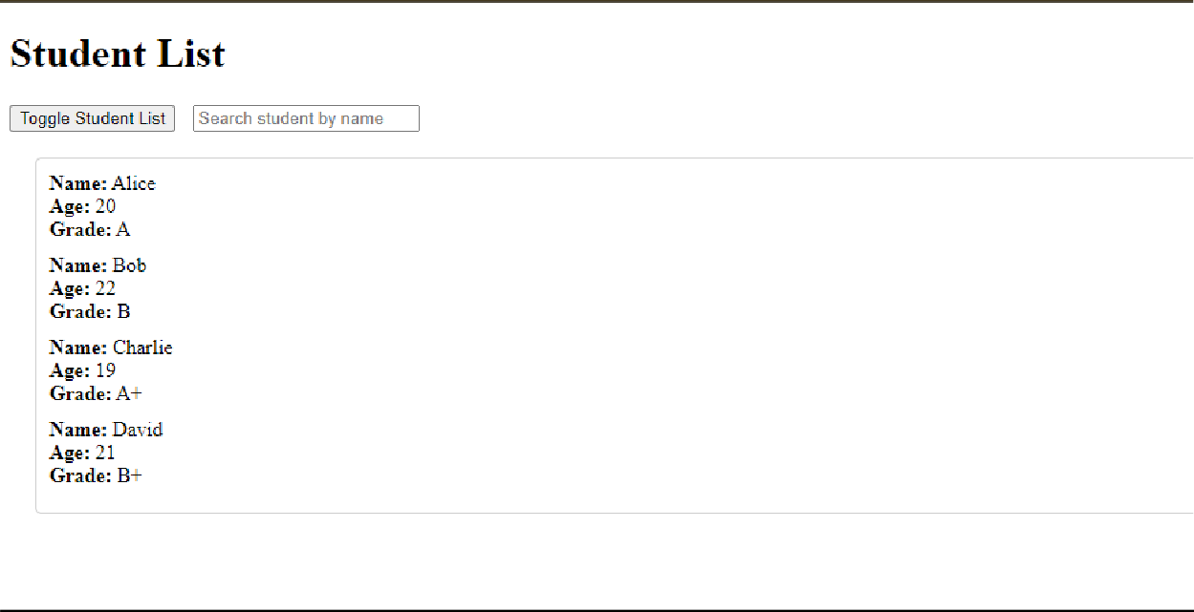
OUTPUT (BEFORE CLICKING TOGGLE):
OUTPUT (AFTER CLICKING TOGGLE):
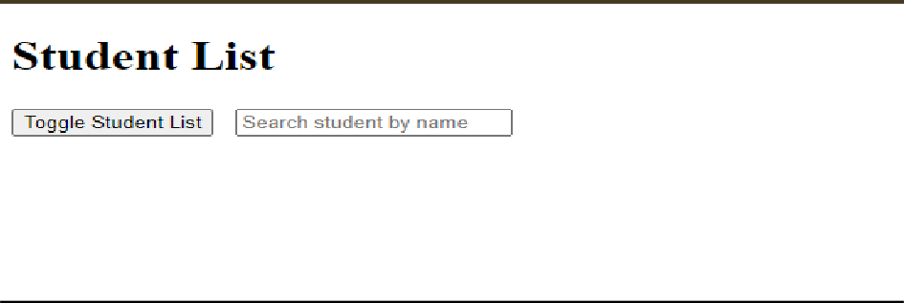
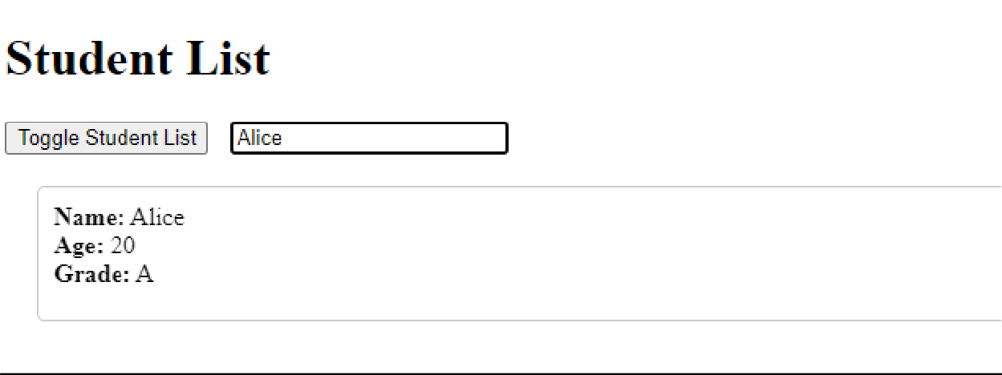
OUTPUT (SEARCHING STUDENT):

HOME TASK:

SOURCE CODE:
<!DOCTYPE html>
<html lang="en">
<head>
<meta charset="UTF-8">
<meta name="viewport" content="width=device-width, initial-scale=1.0">
<title>Home Task - Product Catalog</title>
<script src="https://ajax.googleapis.com/ajax/libs/jquery/3.7.1/jquery.min.js"></scri pt>
<style>
.product {
border: 1px solid #ccc; padding: 10px;
margin: 10px; border-radius: 5px; text-align: center; width: 200px;
}
.product img { width: 100px; height: 100px;
object-fit: cover;
}
.catalog {
display: flex; flex-wrap: wrap;
}
</style>
</head>
<body>
<h1>Product Catalog</h1>
<div>
<label><input type="checkbox" class="categoryFilter" value="Electronics"> Electronics</label>
<label><input type="checkbox" class="categoryFilter" value="Clothing"> Clothing</label>
</div>
<div class="catalog" id="productCatalog">
<!-- Products will be displayed here -->
</div></body></html>

JAVASCRIPT CODE:
<script>
$(document).ready(function () {
// JSON product data const products = [
{ name: "Laptop", price: "$800", description: "High- performance laptop", category: "Electronics", imageUrl: "laptop.jpg", details: "16GB RAM, 512GB SSD" },
{ name: "Smartphone", price: "$500", description: "Latest smartphone", category: "Electronics", imageUrl: "phone.jpg", details: "128GB Storage, 5G" },
{ name: "T-Shirt", price: "$20", description: "Comfortable cotton T-shirt", category: "Clothing", imageUrl: "tshirt.jpg", details: "Available in various sizes" },
{ name: "Jeans", price: "$40", description: "Stylish blue jeans", category: "Clothing", imageUrl: "jeans.jpg", details: "Available in various sizes" },
];

// Display products
function displayProducts(categories = []) {
$("#productCatalog").empty();
const filteredProducts = categories.length === 0
? products
: products.filter(product => categories.includes(product.category));
filteredProducts.forEach(product => {
$("#productCatalog").append(
`<div class="product">
<img src="${product.imageUrl}"

alt="${product.name}">

none;">

);

<h3>${product.name}</h3>
<p>${product.description}</p>
<p><strong>Price:</strong> ${product.price}</p>
<button class="detailsButton">Details</button>
<div class="productDetails" style="display:

<p>${product.details}</p>
</div>
</div>`

});
}

// Initial display displayProducts();

// Filter by category
$(".categoryFilter").change(function () { const selectedCategories =
$(".categoryFilter:checked").map(function () {
return $(this).val();
}).get(); displayProducts(selectedCategories);
});

// Show details
$(document).on("click", ".detailsButton", function () {
$(this).next(".productDetails").slideToggle();
});
});
</script>
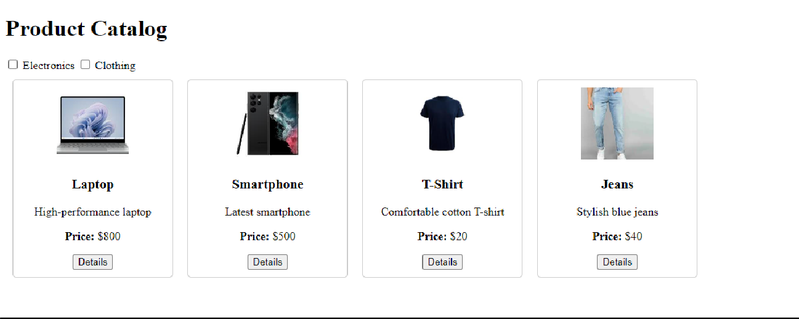
OUTPUT (BEFORE SELECTING CATEGORY):
OUTPUT (SELECTING CATEGORY):
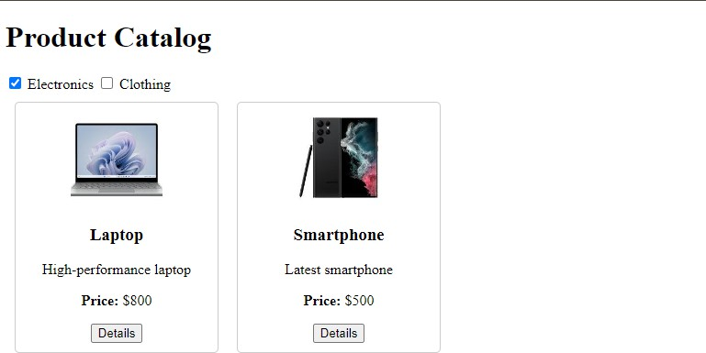


ABSAR AHMED CHOHAN
LAB 9

LAB TASK SOURCE CODE:
import React, { useState } from 'react'; import './App.css';
const students = [
{ name: "Alice", age: 20, skills: ["JavaScript", "React", "CSS"] },
{ name: "Bob", age: 22, skills: ["Java", "Spring Boot", "SQL"] },
{ name: "Charlie", age: 21, skills: ["Python", "Django", "Data Analysis"]
},
];

const App = () => { return (
<div>
<h1>Student Information App</h1>
<StudentList />
</div>
);
};

const StudentList = () => {
const [showMore, setShowMore] = useState(Array(students.length).fill(false));

const toggleShowMore = (index) => { const updatedShowMore = [...showMore];
updatedShowMore[index] = !updatedShowMore[index]; setShowMore(updatedShowMore);
};

return (
<div>
{students.map((student, index) => (
<div key={index} style={{ marginBottom: "20px" }}>
<h3>{student.name}</h3>
<p>Age: {student.age}</p>
{showMore[index] && (
<p>Skills: {student.skills.join(", ")}</p>
)}
<button onClick={() => toggleShowMore(index)}>

{showMore[index] ? "Show Less" : "Show More"}
</button>
</div>
))}
</div>
);
};

export default App;

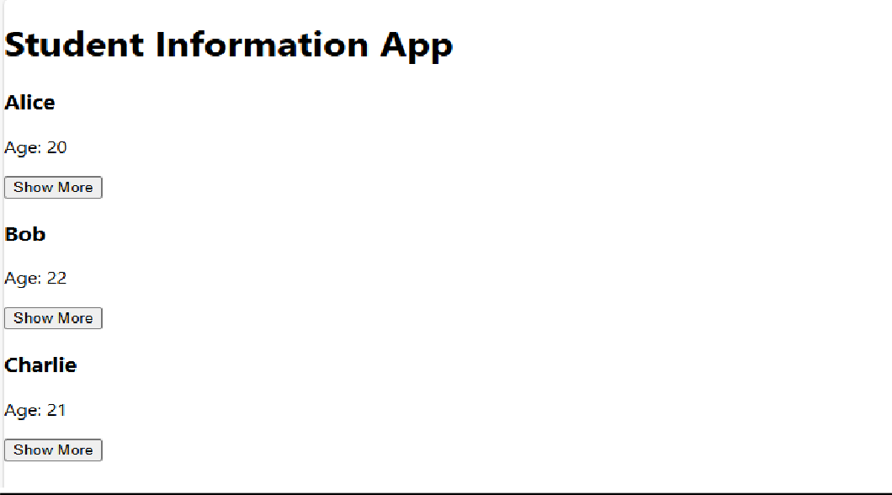
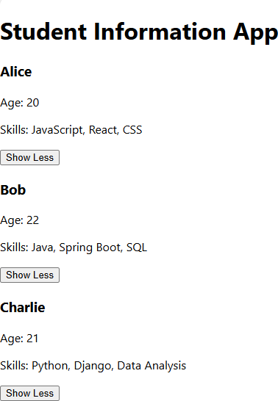
OUTPUT (WITHOUT CLICKING BUTTON):
OUTPUT (AFTER CLICKING):

HOME TASK: SOURCE CODE:
import React, { useState } from "react";

const products = [
{
name: "Laptop", price: "$1000",
description: "High-performance laptop",
details: "16GB RAM, 1TB SSD, Intel i7 Processor",
reviews: ["Excellent product!", "Very fast and reliable."],
},
{
name: "Phone",
price: "$500",
description: "Smartphone with a great camera", details: "128GB Storage, 48MP Camera, 5G",
reviews: ["Great camera quality.", "Battery life could be better."],
},
];

const App = () => { return (
<div>
<h1>Product Catalog</h1>
<ProductList />
</div>
);
};

const ProductList = () => {
const [showMore, setShowMore] = useState(Array(products.length).fill(false));

const toggleShowMore = (index) => { const updatedShowMore = [...showMore];
updatedShowMore[index] = !updatedShowMore[index]; setShowMore(updatedShowMore);
};

return (

<div style={{ display: "grid", gridTemplateColumns: "1fr 1fr", gap: "20px" }}>
{products.map((product, index) => (
<div key={index} style={{ border: "1px solid #ddd", padding: "20px" }}>
<h3>{product.name}</h3>
<p>Price: {product.price}</p>
<p>{product.description}</p>
{showMore[index] && (
<div>
<p><strong>Details:</strong> {product.details}</p>
<p><strong>Reviews:</strong> {product.reviews.join(" |
")}</p>
</div>
)}
<button onClick={() => toggleShowMore(index)}>
{showMore[index] ? "Show Less" : "Show More"}
</button>
</div>
))}
</div>
);
};

export default App;

OUTPUT (BEFORE CLICKING):
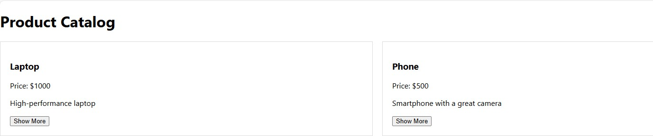
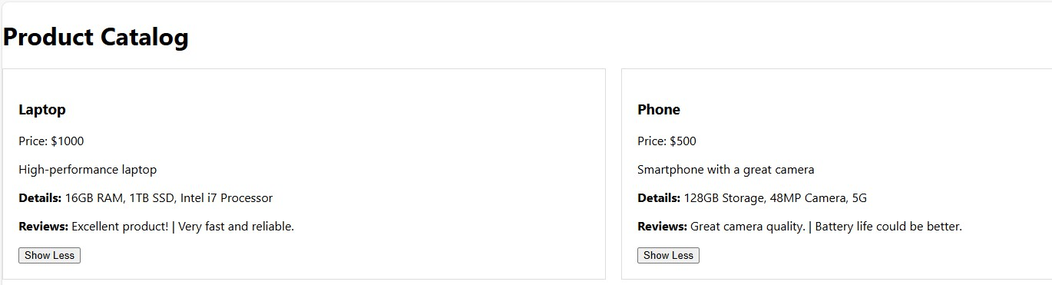
OUTPUT (AFTER CLIKCING):


ABSAR AHMED CHOHAN
LAB 10

LAB TASK:

SOURCE CODE:
using Microsoft.AspNetCore.Mvc; using System.Collections.Generic;
namespace WebApplication1.Controllers
{
[Route("api/[controller]")] [ApiController]
public class ProductCatalogController : ControllerBase
{
// Static list to simulate a product catalog
private static List<Product> products = new List<Product>
{
new Product { Id = 1, Name = "Laptop", Price = 1000, Description = "High-performance laptop" }, new Product { Id = 2, Name = "Phone", Price = 500, Description = "Smartphone with a great camera" }
};

// GET api/productcatalog [HttpGet]
public ActionResult<List<Product>> Get()
{
return Ok(products);
}
// POST api/productcatalog [HttpPost]
public ActionResult<Product> Post([FromBody] Product product)
{
if (string.IsNullOrEmpty(product.Name) || product.Price <= 0)
{
return BadRequest("Product name and price are required.");
}

products.Add(product);
return CreatedAtAction(nameof(Get), new { id = product.Id }, product);
}
}
public class Product
{
public int Id { get; set; }
public string Name { get; set; } public double Price { get; set; } public string Description { get; set; }
}}
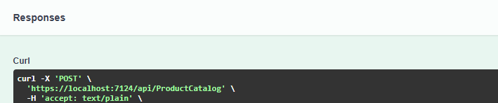
OUTPUT:

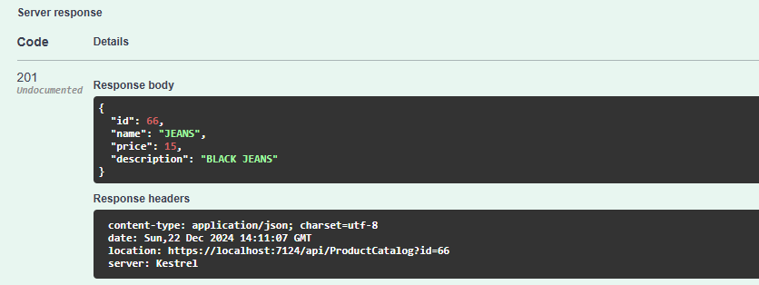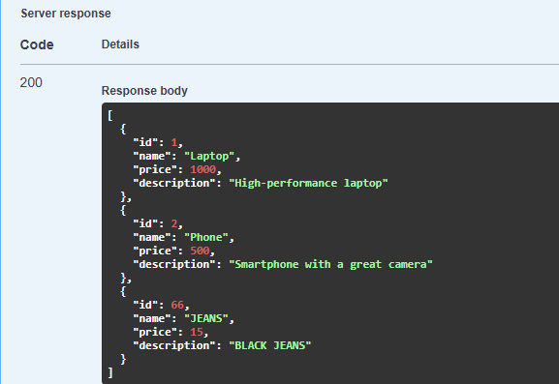
HOME TASK:

HTTP Methods: Definitions and Use Cases

HTTP methods are used to perform various operations on resources in a web application. Here are the main HTTP methods:
  - GET:
Retrieves data from the server.
Use case: Fetching a list of products or details of a single product.

Example:

Csharp

[HttpGet]
public IEnumerable<Product> GetProducts() { ... }

POST:
Sends data to the server to create a new resource. Use case: Adding a new product to the inventory. Example:

csharp

[HttpPost]
public IActionResult AddProduct([FromBody] Product product) { ...
}

  - PUT:
Updates an existing resource on the server.
Use case: Updating the details of an existing product.

Example:

csharp

[HttpPut("{id}")]
public IActionResult UpdateProduct(int id, [FromBody] Product product) { ... }

DELETE:
Deletes a resource on the server.
Use case: Removing a product from the database.

Example:

csharp

[HttpDelete("{id}")]
public IActionResult DeleteProduct(int id) { ... }

PATCH:
Partially updates a resource.

Use case: Modifying only the price of a product.

Example:

csharp

[HttpPatch("{id}")]
public IActionResult UpdatePrice(int id, [FromBody] decimal price) { ... }

HEAD:
Similar to GET, but retrieves only headers and not the body.
Use case: Checking if a resource exists without downloading it.

OPTIONS:
Describes the communication options for the target resource.
Use case: Checking the allowed HTTP methods for a particular endpoint.

- Purpose of [ApiController] and [Route] Attributes in WebAPI

  - [ApiController] Attribute:
    - Marks the class as a WebAPI controller, enabling WebAPI-specific behaviors.
    - Features:
      - Automatic model validation: Returns 400 Bad Request if model validation fails.
      - Simplifies parameter binding: Automatically binds route data, query parameters, and request body to method parameters.
      - Assumes JSON input/output by default.

Example:

csharp [ApiController]
public class ProductsController : ControllerBase { ... }

  - [Route] Attribute:
    - Defines the route template for a controller or action.
    - Supports placeholders for dynamic values (e.g., {id}).

Example:

csharp [Route("api/[controller]")]

public class ProductsController : ControllerBase { ... }

Default JSON Serialization in WebAPI
  - JSON Serialization: WebAPI uses System.Text.Json (or Newtonsoft.Json in older projects) for serializing and deserializing JSON data.

Key Features:
    - Converts objects to JSON and vice versa.
    - Handles cyclic references gracefully with configuration.
    - Allows customization of property naming conventions (e.g., camelCase).

Example:

csharp services.AddControllers().AddJsonOptions(options =>
{
options.JsonSerializerOptions.PropertyNamingPolicy = JsonNamingPolicy.CamelCase;
});


LAB 11

TASK 1:

Source Code (STUDENT CONTROLLER):
using Microsoft.AspNetCore.Mvc; using WebApplication2.Models;
using Microsoft.EntityFrameworkCore;

[ApiController] [Route("api/[controller]")]
public class StudentsController : ControllerBase
{
private readonly LabDatabaseContext _context;

public StudentsController(LabDatabaseContext context)
{
_context = context;
}

[HttpGet]
public async Task<ActionResult<IEnumerable<Student>>> GetStudents()
{
var students = await _context.Students.ToListAsync(); return Ok(students);
}

[HttpGet("{id}")]
public async Task<ActionResult<Student>> GetStudent(int id)
{
var student = await _context.Students.FindAsync(id);

if (student == null)
{
return NotFound();
}
return Ok(student);
}
// POST: api/students [HttpPost]
public async Task<ActionResult<Student>> PostStudent(Student student)
{
// Check if the model is valid if (!ModelState.IsValid)
{
return BadRequest(ModelState);
}

// Add the student to the database
_context.Students.Add(student); await _context.SaveChangesAsync();

// Return the created student with a 201 status code
return CreatedAtAction(nameof(GetStudent), new { id = student.StudentId }, student);
}}

Source Code (STUDENT MODEL):
namespace WebApplication2.Models;

public class Student
{
public int StudentId { get; set; } public string Name { get; set; } public int Age { get; set; }
}

Source Code (DATABASE CONNECTION):
using System;
using System.Collections.Generic; using Microsoft.EntityFrameworkCore;
namespace WebApplication2.Models;
public partial class LabDatabaseContext : DbContext
{
public LabDatabaseContext()
{
}

public LabDatabaseContext(DbContextOptions<LabDatabaseContext> options)
: base(options)
{
}
protected override void OnConfiguring(DbContextOptionsBuilder optionsBuilder)

=> optionsBuilder.UseSqlServer("Server=DESKTOP- TI3IL06\\SQLEXPRESS;Database=LabDatabase;Trusted_Connection=True;TrustServerCertificate=True
;");
protected override void OnModelCreating(ModelBuilder modelBuilder)
{
OnModelCreatingPartial(modelBuilder);
}
partial void OnModelCreatingPartial(ModelBuilder modelBuilder); public virtual DbSet<Student> Students { get; set; }
}

SOURCE CODE(appsetting.js):
{
"Logging": {
"LogLevel": {
"Default": "Information", "Microsoft.AspNetCore": "Warning"
}

},
"AllowedHosts": "*", "ConnectionStrings": {
"DefaultConnection": "Server=DESKTOP- TI3IL06\\SQLEXPRESS;Database=LabDatabase;Trusted_Connection=True;TrustServerCertificate=True
;"
}

}
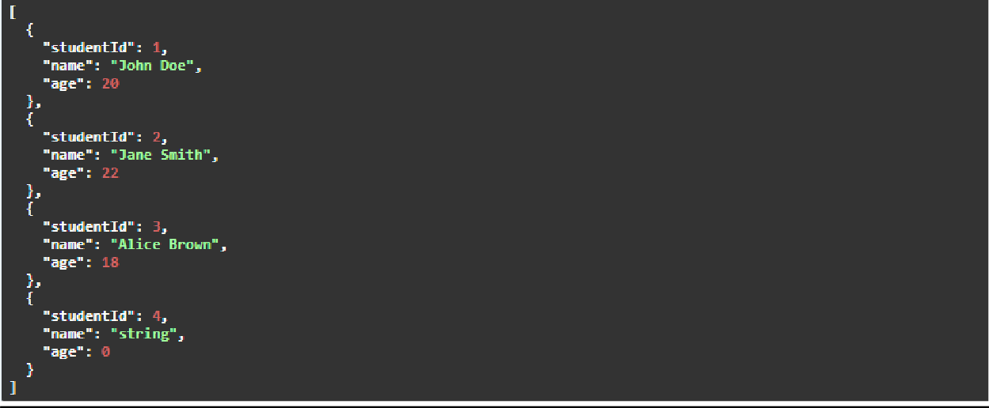
OUTPUT (GET):
OUTPUT (SET):

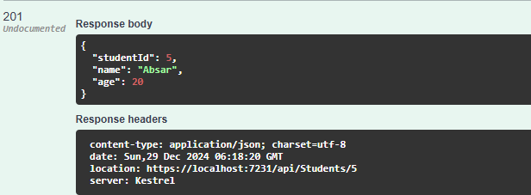
TASK 2:

SOURCE CODE: (STUDENTCONTROLLER.cs):
using Microsoft.AspNetCore.Mvc; using WebApplication2.Models;
using Microsoft.EntityFrameworkCore;
[ApiController] [Route("api/[controller]")]

public class StudentsController : ControllerBase
{
private readonly LabDatabaseContext _context;
public StudentsController(LabDatabaseContext context)
{
_context = context;
}

// GET: api/students [HttpGet]
public async Task<ActionResult<IEnumerable<Student>>> GetStudents([FromQuery] int? age)
{
try
{
// LINQ Query: Filter students based on age if the query parameter is provided var students = _context.Students.AsQueryable();

if (age.HasValue)
{
students = students.Where(s => s.Age > age.Value);
}

return Ok(await students.ToListAsync());
}
catch (Exception ex)
{
return StatusCode(500, $"Internal server error: {ex.Message}");
}
}
// GET: api/students/{id} [HttpGet("{id}")]
public async Task<ActionResult<Student>> GetStudent(int id)
{
var student = await _context.Students.FindAsync(id);

if (student == null)
{
return NotFound();
}

return Ok(student);
}

// POST: api/students [HttpPost]
public async Task<ActionResult<Student>> PostStudent(Student student)
{
// Check if the model is valid if (!ModelState.IsValid)
{

return BadRequest(ModelState);
}
// Add the student to the database
_context.Students.Add(student);

// Save changes to the database
await _context.SaveChangesAsync();

// Return the created student with a 201 status code
return CreatedAtAction(nameof(GetStudent), new { id = student.StudentId }, student);
}
}
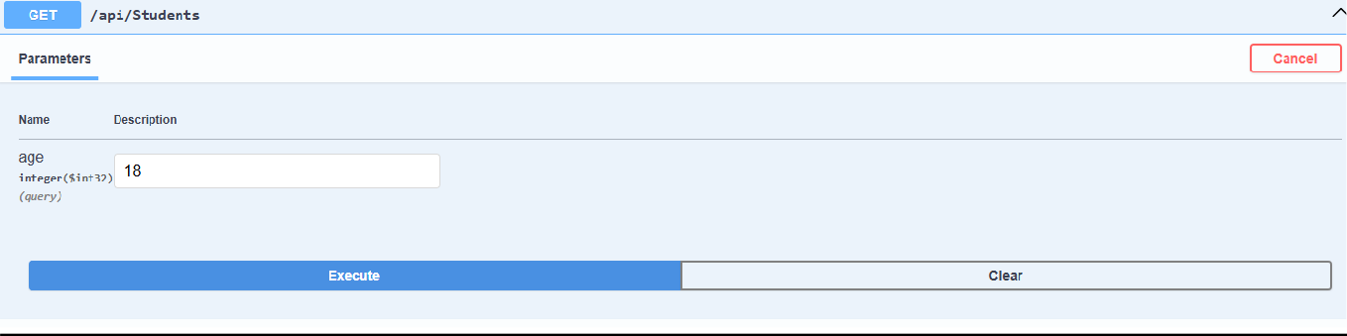
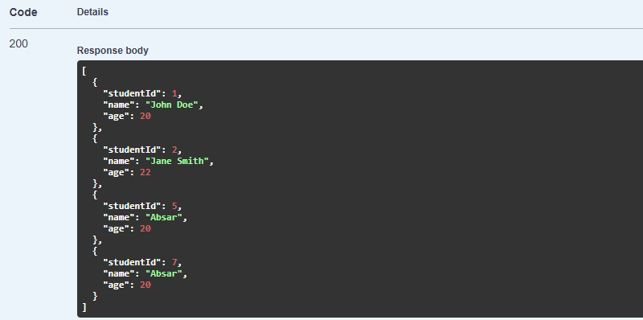
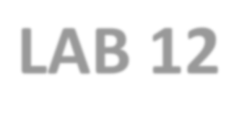
OUTPUT:

LAB 12
TASK 1:
SOURCE CODE (PRODUCTCONTROLLER.cs):

using Microsoft.AspNetCore.Http; using Microsoft.AspNetCore.Mvc; using Microsoft.EntityFrameworkCore;
using LabWebApi.Models; // Assuming you have a Models folder for Product entity
namespace LabWebApi.Controllers
{
[Route("api/[controller]")] [ApiController]
public class ProductsController : ControllerBase
{

private readonly LabDatabaseContext _context;
public ProductsController(LabDatabaseContext context)
{
_context = context;
}
// 1. Get all products [HttpGet]
public async Task<IActionResult> GetProducts()
{
var products = await _context.Products.ToListAsync(); return Ok(products);
}
// 2. Get a product by ID [HttpGet("{id}")]
public async Task<IActionResult> GetProduct(int id)
{
var product = await _context.Products.FindAsync(id);
if (product == null)
{
return NotFound();
}

return Ok(product);
}
// 3. Add a new product [HttpPost]
public async Task<IActionResult> AddProduct(Product product)
{
if (!ModelState.IsValid)
{
return BadRequest(ModelState);
}
_context.Products.Add(product); await _context.SaveChangesAsync();
return CreatedAtAction(nameof(GetProduct), new { id = product.Id }, product);
}

// 4. Update an existing product [HttpPut("{id}")]
public async Task<IActionResult> UpdateProduct(int id, Product product)
{
if (id != product.Id)
{

return BadRequest("Product ID mismatch.");
}
_context.Entry(product).State = EntityState.Modified; try
{
await _context.SaveChangesAsync();
}
catch (DbUpdateConcurrencyException)
{
if (!_context.Products.Any(e => e.Id == id))
{
return NotFound();
}
else
{
throw;
}
}
return NoContent(); // Return 204 (No Content) when successfully updated
}
// 5. Delete a product [HttpDelete("{id}")]
public async Task<IActionResult> DeleteProduct(int id)
{
var product = await _context.Products.FindAsync(id); if (product == null)
{
return NotFound();
}
_context.Products.Remove(product); await _context.SaveChangesAsync();

return NoContent(); // Return 204 (No Content) after successful deletion
}
}
}
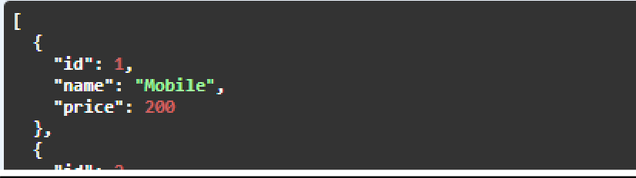
OUTPUT (PUT METHOD / UPDATE):

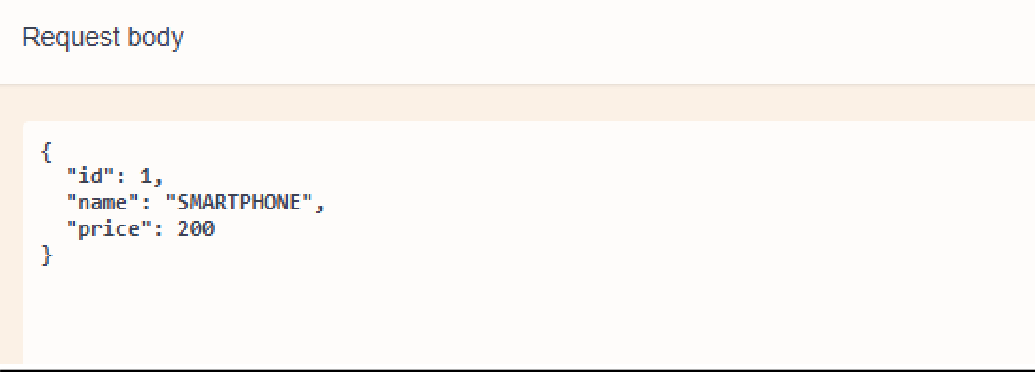

AFTER UPDATION:

OUTPUT (DELETE METHOD):

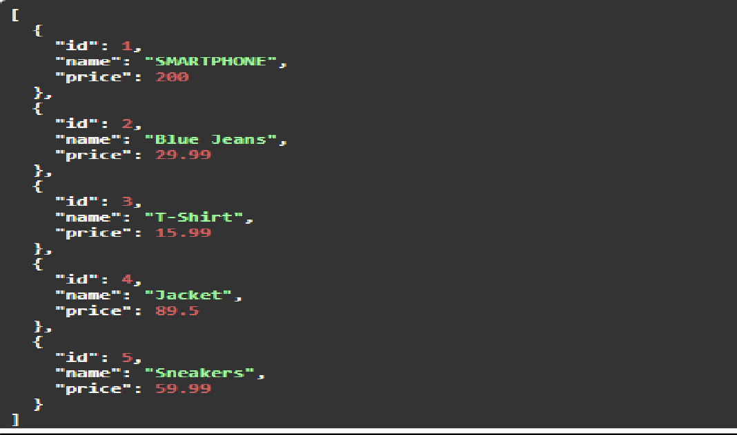
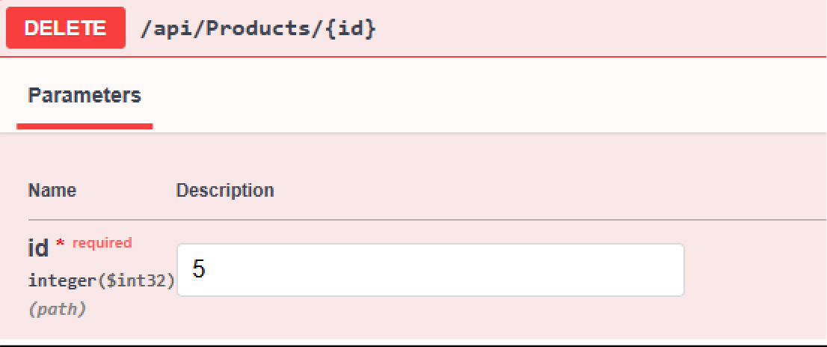
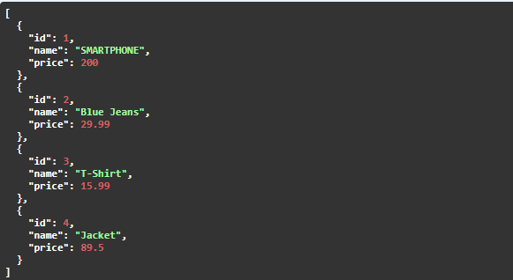
AFTER DELETION:
Review Questions

- Explain how Web API endpoints are created and consumed.

How Web API endpoints are created and consumed:
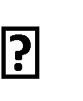
Creating Endpoints:
  - In ASP.NET Core, Web API endpoints are created by defining a controller class with the [ApiController] attribute and routing via [Route("api/[controller]")].
  - HTTP methods like [HttpGet], [HttpPost], [HttpPut], and [HttpDelete] correspond to actions like fetching, creating, updating, and deleting data.
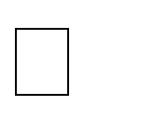
Consuming Endpoints:
  - You can consume Web API endpoints using tools like HttpClient in .NET, which allows sending HTTP requests and receiving responses asynchronously.
- What is the advantage of using HTTPClient for API consumption?

Advantages of using HttpClient for API consumption:
  - Reusable: HttpClient should be reused for multiple requests to avoid issues like socket exhaustion.
  - Asynchronous: Supports async calls, improving performance in I/O-bound operations.
  - Customizable: Allows you to set headers, timeouts, and authentication for requests.
  - Error Handling: Provides built-in methods to handle different response statuses.
  - Content Serialization: Simplifies handling JSON or XML data and converting it into .NET objects.


WEB ENGINEERING LAB 2022F-BCS-066
LAB 13
ABSAR AHMED CHOHAN

Analyze the Database Connection Errors

Root Causes:
  - Network instability: Intermittent network issues can lead to database connection failures.
  - Connection Pool Exhaustion: If too many concurrent connections are made to the database, it may run out of available connections.
  - Timeouts: Long-running queries or high database load may result in connection timeouts.
  - Database Configuration: Improper configuration of connection strings (e.g., incorrect server names or credentials).

Solutions:

  - Implement Retry Policies: Use libraries like Polly to implement retries with exponential backoff when a database connection fails.
  - Database Redundancy: Set up database replication to provide failover mechanisms in case the primary database server becomes unavailable.
  - Connection String Configuration: Ensure the connection string is correctly configured, including setting timeouts and connection pooling parameters. A sample configuration:
  - Server=myServerAddress;Database=myDataBase;User Id=myUsername;Password=myPassword;Connect Timeout=30;

Prevention Strategy:
  - Monitoring: Set up automated monitoring for database connectivity.
  - Testing: Regularly test failover and redundancy setups.
  - Capacity Planning: Ensure the database can handle peak loads by scaling vertically or horizontally.

Address the Performance Degradation During Peak Hours

Root Causes:
  - High Traffic: The application may become slow due to increased requests that the current infrastructure cannot handle.
  - Resource Saturation: Lack of sufficient resources (CPU, memory, or database) can cause slower response times.
  - Inefficient Database Queries: Poorly optimized queries can significantly impact performance, especially during high traffic.

Solutions:
  - Implement Caching: Cache frequently accessed data to reduce the number of database queries. Use tools like Redis or in-memory caching.
  - Auto-Scaling: Enable auto-scaling in cloud environments like Azure, which automatically adjusts resources based on demand.
  - Database Query Optimization: Review and optimize queries, add indexes, and ensure proper query plans are in place.

Prevention Strategy:
  - Load Testing: Regularly perform load testing to ensure the application can handle increased traffic.
  - Proactive Scaling: Set up auto-scaling rules to add resources before the application reaches its limits.
  - Database Optimization: Continuously optimize database queries and indexing strategies to improve response time.

Resolve the Incomplete Logs Issue

Root Causes:
  - Lack of Structured Logs: Unstructured or inconsistent logs make it difficult to diagnose issues.
  - Missing Log Data: Essential information such as error codes, timestamps, and user IDs might not be logged, making it difficult to trace issues.

Solutions:

  - Implement Structured Logging: Use structured logging frameworks like Serilog to ensure logs are consistently formatted and easily queryable.
  - Log.Information("User {UserId} logged in at {Timestamp}", userId, DateTime.Now);
  - Integrate with Azure Monitor or Application Insights: These tools provide centralized log management and enable real-time monitoring.
  - Capture Essential Information: Ensure logs capture critical data such as error messages, stack traces, user actions, and transaction details.

Prevention Strategy:
  - Centralized Logging: Implement a centralized logging solution (e.g., ELK stack, Azure Monitor) to capture logs from all parts of the system.
  - Log Retention Policies: Set up log retention policies to ensure important logs are retained for future analysis.

  - Proactive Monitoring: Continuously monitor logs for anomalies using alerting systems in tools like Application Insights.

Step-by-Step Solutions:

Database Connection Errors:
  - Step 1: Use retry policies (e.g., Polly library) to handle transient connection issues.
  - Step 2: Configure a redundant database setup with failover.
  - Step 3: Optimize the connection string and ensure proper timeout and pooling settings.

Performance Degradation:
  - Step 1: Implement caching mechanisms for frequently requested data.
  - Step 2: Enable auto-scaling for the application and database to handle high traffic.
  - Step 3: Analyze and optimize database queries, including indexing and query restructuring.

Incomplete Logs:
  - Step 1: Integrate structured logging frameworks like Serilog for consistent logging.
  - Step 2: Implement log aggregation tools like Azure Monitor or ELK Stack.
  - Step 3: Capture essential information and error details in logs, and ensure logs are accessible for analysis.

Preventive Measures:
- Database: Set up automated monitoring for database health and use a centralized logging system.
- Performance: Perform stress tests and ensure proactive scaling capabilities.
- Logging: Regularly audit logs and set up alerts for critical issues.

By following these steps, you will be able to resolve existing issues and ensure better application performance and monitoring in the future.

